**What is a Needs Assessment?**

**Supplementary Reading**

A 'Needs Assessment' can be defined by the following process:

* Comprehensive identification of all key strengths and barriers than an individual experiences

* Identification of the relevant activities of the person undertaking the Needs Assessment (e.g. day-to-day living; workplace; education), and subsequently how those activities are impacted upon by the barriers associated with the ‘disability’; these can be termed as the 'practical difficulties' of the individual.

* The recommendation of strategic approaches to help overcome practical difficulties: these strategies can involve adaptations to the activities or working environments of the disabled person by the organisation (e.g. employer; educational institution; public organisation) responsible for those activities and environments (these can referred to as 'Reasonable Adjustments'); the application of tools and equipment (commonly referred to as 'Assistive Technology'); and support from other people (either in voluntary or professional capacities).

A formalised Needs Assessment process will typically involve a one-to-one interview followed by provision of a written report. The report would typically document the interview, detailing the barriers, activities, challenges of the disabled person, alongside the strategies recommended by the Needs Assessor.

These recommendations should be detailed and justified. The manner in which the information and recommendations are presented in the written report is determined by the party for whom the report is written; relevant parties include the disabled person and their family, the organisation with which the disabled person is engaged (e.g. employer; educational institution), and, in the case that recommendations for funded support are being made, a funding body.

# Process and context

Fundamentally, the Needs Assessment is a signposting exercise, drawing upon the information gathered from the disabled person in order to suggest a productive pathway forward. When the Needs Assessor is making recommendations for funded support, there is typically a necessity in presenting those recommendations in a relatively emphatic and conclusive manner. However, when the Needs Assessor is focused primarily on Assistive Technology that is either free or affordably priced, as well as considering any relevant reasonable adjustments, the Needs Assessor is able to fully embrace the uncertainties inherent in making speculative recommendations for support.

The Needs Assessor cannot be certain of the impact of a strategy at the point that it is recommended, and this means that the Needs Assessor must be prepared for all of the recommended strategies to fail. This is regrettable, but the failure of the strategies should not be put down to a failure of the Needs Assessor or the Needs Assessment.

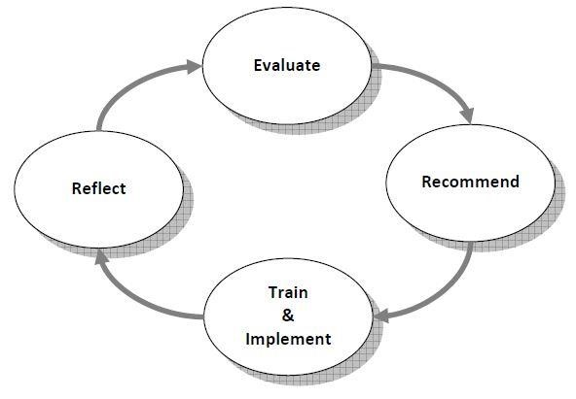

# The Needs Assessor: core skills and knowledge

There are several core skills and areas of knowledge that a necessary for the Needs Assessor to be effective in practice. While the Needs Assessor is working to, and is in control of, a process, the Needs Assessment a human interaction that cannot function effectively without the active engagement of both participants. Therefore, the conduct and communication of the Needs Assessor are critical to the success of the Needs Assessment, as much as the requirement for sufficient knowledge in the areas of disability and Assistive Technology. As the Needs Assessor is practising, it is healthy to maintain ongoing commitment to formal training; peer support and information sharing with other Needs Assessors; formal observation and appraisal; and engagement with information resources, both physical and digital.

The core areas of skills and knowledge for a Needs Assessor are as follows:

# Skills

* Communication in person, both oral and physical
* Communication in writing
* Lateral thinking
* A thorough and meticulous nature

# Knowledge

* Disability: impacts and barriers, social model understanding
* Strategies, adjustments, and solutions for addressing barriers
* Contextual knowledge regarding the relevant activities of the disabled person undertaking the Needs Assessment (e.g. knowledge of educational environment or workplace)

While an intuitive ability to think laterally is very useful when connecting difficulties to potential solutions, this is also a capacity that grows with the Needs Assessor's familiarity with the functionality of the Assistive Technology.

Fundamentally, the Needs Assessor has an ethical duty to deliver a Needs Assessment that is as comprehensive as possible, in terms of both a thorough exploration of all areas of activity that are affected by disability, and the potential solutions to those difficulties. It is advisable for the Needs Assessor to maintain awareness of the power that they hold within the context of the Needs Assessment, which requires a disabled person to honestly expose their difficulties and challenges, often for the first time in a formal setting, and this is something that can be very difficult for some people to do.

These challenges must be handled with great care, while the Needs Assessor must also seek to maintain humility in the interaction, recognising the limitations of their capacity to help and being mindful of any desire to 'save' the disabled person from a difficult situation.

This helps to keep the disabled person at the centre of the Needs Assessment process and also helps the Needs Assessor to remain agile in adapting their conduct of the Needs Assessment to the needs of the disabled person that they are talking to.